A Project Stage-II Report On

ENHANCED DIABETIC RETINOPATHY CLASSIFICATION WITH MULTIPOINT ATTENTION AND SEMISUPERVISED LEARNING

Submitted in partial fulfillment of the requirements for the award of the degree of

BACHELOR OF TECHNOLOGY
in

COMPUTER SCIENCE & ENGINEERING

from

JAWAHARLAL NEHRU TECHNOLOGICAL UNIVERSITY HYDERABAD

By
Vinitha Kandula (21C11A05J0)
Srilekha Bayyapu (21C11A05G0)
Srikruthi Dorapally (22C15A0517)
Sruthi Garidepalli (21C11A05G2)
Tejasri Chundru (21C11A05G7)
Under the guidance of

Mrs. M. Anusha MTech/Ph.D.
Assistant Professor

DEPARTMENT OF COMPUTER SCIENCE & ENGINEERING

 | ANURAG ENGINEERING COLLEGE  (An Autonomous Institution)  (Affiliated to JNTUH, Hyderabad& Approved by AICTE, New Delhi)  Ananthagiri(V&M),Kodad, Suryapet(Dt.),Telangana-508206.  2024 – 25 | 

ANURAG ENGINEERING COLLEGE
(An Autonomous Institution)
(Affiliated to JNTUH, Hyderabad & Approved by AICTE, New Delhi)
Ananthagiri(V & M), Kodad, Suryapeta(Dt),Telangana-508206.

DEPARTMENT OF COMPUTER SCIENCE & ENGINEERING

CERTIFICATE

This is to certify that the project work entitled “ENHANCED DIABETIC RETINOPATHY CLASSIFICATION WITH MULTIPOINT ATTENTION AND SEMISUPERVISED LEARNING” is a Bonafide work done by “VINITHA KANDULA (21C11A05J0)” in the partial fulfillment for the award of Bachelor of Technology in Computer Science & Engineering from JNTUH, Hyderabad during the year2024-25.
This work has not been submitted to any other university or institute or organization for the award of any degree or diploma.

Mrs. M .Anusha  Supervisor |  | Dr. Y.V.R. Naga Pawan  H.O.D.
External Examiner |  | Dr. T. Suresh Kumar  Principal

ANURAG ENGINEERING COLLEGE
(An Autonomous Institution)
(Affiliated to JNTUH, Hyderabad & Approved by AICTE, New Delhi)
Ananthagiri(V & M), Kodad, Suryapeta(Dt),Telangana-508206.

DEPARTMENT OF COMPUTER SCIENCE & ENGINEERING

CERTIFICATE

This is to certify that the project work entitled “ENHANCED DIABETIC RETINOPATHY CLASSIFICATION WITH MULTIPOINT ATTENTION AND SEMISUPERVISED LEARNING” is a Bonafide work done by “VINITHA KANDULA(21C11A05J0), SRILEKHA BAYYAPU (21C11A05G0),SRIKRUTHI DORAPALLY(22C15A0517),SRUTHI GARIDEPALLY(21C11A05G2),TEJASRI CHUNDRU(21C11A05G7)” in the partial fulfillment for the award of Bachelor of Technology in Computer Science & Engineering from JNTUH, Hyderabad during the year 2024-25.
This work has not been submitted to any other university or institute or organization for the award of any degree or diploma.

Mrs.M.Anusha  Supervisor |  | Dr. Y.V.R. Naga Pawan  H.O.D.
External Examiner |  | Dr. T. Suresh Kumar  Principal

ACKNOWLEDGEMENTS

This report will certainly not be completed without due acknowledgement paid to all those who helped me during this project work.
I express sincere thanks to my supervisor Mrs. M .Anusha, for giving moral support, kind attention and valuable guidance throughout this project work.
It is my privilege to thank Dr.Y.V.R.Naga Pawan, Head of the Department, for his encouragement during the progress of this project work.
I am thankful to both Teaching and non-teaching staff members of Department of Computer Science & Engineering for their kind cooperation and all sorts of support in bringing out this project work successfully.
I derive great pleasure in expressing my sincere gratitude to the principal Dr.T. Suresh Kumar for his timely suggestions, which helped me to complete this work successfully.
I am thankful to the Management of ANURAG Engineering College for providing required facilities during the project work.
I would like to thank my parents and my friends for being supportive all the time, and I am very much obliged to them.

VINITHA KANDULA

(21C11A05J0)

ACKNOWLEDGEMENTS

This report will certainly not be completed without due acknowledgement paid to all those who helped me during this project work.
We express sincere thanks to my supervisor Mrs.M.Anusha, for giving moral support, kind attention and valuable guidance throughout this project work.
It is our privilege to thank Dr.Y.V.R.Naga Pawan, Head of the Department, for his encouragement during the progress of this project work.
We are thankful to both Teaching and non-teaching staff members of Department of Computer Science & Engineering for their kind cooperation and all sorts of support in bringing out this project work successfully.
We derive great pleasure in expressing my sincere gratitude to the principal Dr.T. Suresh Kumar for his timely suggestions, which helped us to complete this work successfully.
We are thankful to the Management of ANURAG Engineering College for providing required facilities during the project work.
We would like to thank my parents and my friends for being supportive all the time, and we are very much obliged to them.

VINITHA KANDULA (21C11A05J0),
SRILEKHA BAYYAPU (21C11A05G0),
SRIKRUTHI DORAPALLY(22C15A0517),
SRUTHI GARIDEPALLY(21C11A05G2),
TEJASRI CHUNDRU(21C11A05G7)

CONTENTS

Problem Statement |  | ii
List Of Figures |  | iii
List Of Tables |  | iv
List Of Acronyms |  | v
1 | Introduction
2 | Objectives
3 | Existing System
4 | Proposed System
5 | System Architecture
6 | Technologies Used
7 | Software Requirements
8 | Hardware Requirements
9 | Modules
10 | Design Diagrams
11 | Sample Code
12 | Results
13 | Test Cases
14 | Limitations
15 | Conclusion
16 | Future Enhancements
References

Problem Statement

To propose a model on improving diabetic retinopathy (DR)
classification by incorporating a Multi-Point Attention Mechanism to better identify critical features in retinal images. It utilizes Semi-Supervised Learning to make use of both labeled and unlabeled data, alleviating the need for large labeled datasets. The objective is to create a deep learning model that is both accurate and efficient for early DR detection. By enhancing the model’s focus on important areas, it aims to improve classification performance and reduce the reliance on manual annotation. The ultimate goal is to provide a scalable and accessible solution for DR screening in healthcare.

List Of Figures

Figure No. | Description | Page No.

List Of Tables

Table No. | Description | Page No.

List Of Acronyms

CNN | Convolutional Neural Network
DR | Diabetic Retinopathy
ETDRS | Early Treatment Diabetic Retinopathy Study
HIPAA | Health Insurance Portability and Accountability Act
KNN | K-Nearest Neighbours
NPDR | Non-Proliferative Diabetic Retinopathy
OCT | Optical Coherence Tomography
OpenCV | Open-Source Computer Vision Library
PDR | Proliferative Diabetic Retinopathy

CHAPTER 1

INTRODUCTION

1.1 Basic Introduction

Diabetic retinopathy (DR) is a widespread complication of diabetes, particularly in individuals with high blood sugar and hypertension, which can lead to vision loss and even blindness. As the prevalence of diabetes continues to grow, early detection becomes vital to avoid serious consequences. However, the large volume of cases and the specialized knowledge needed for precise diagnosis pose significant challenges for ophthalmologists. Therefore, creating an automated system for DR diagnosis is crucial for faster and more accurate identification, utilizing classification methods such as the Early Treatment Diabetic Retinopathy Study (ETDRS) scale.

1.2 Stages of Diabetic Retinopathy

The ETDRS scale classifies diabetic retinopathy into several stages:

No Diabetic Retinopathy (No DR): No abnormalities are found in the retina.

Mild Non-Proliferative Diabetic Retinopathy (NPDR): The presence of microaneurysms (small bulges in blood vessel walls), which marks the earliest stage of DR.

Moderate Non-Proliferative Diabetic Retinopathy (NPDR): In addition to microaneurysms, more extensive retinal changes occur, such as hemorrhages (bleeding) and hard exudates (yellowish deposits).

Severe Non-Proliferative Diabetic Retinopathy (NPDR): This stage features more significant changes in retinal blood vessels, including widespread hemorrhages and cotton-wool spots (swollen areas in the retinal nerve fiber layer).

Proliferative Diabetic Retinopathy (PDR): The most advanced stage, characterized by the growth of new blood vessels on the retina’s surface and into the vitreous body. This can lead to bleeding, scar tissue formation, and potential retinal detachment.

These stages are essential for determining appropriate treatment and intervention strategies. Early detection and classification, supported by advanced imaging technologies and AI systems, play a key role in guiding timely medical care and preventing vision impairment.

Here is an Introduction to Diabetic Retinopathy Classification

Diabetic Retinopathy (DR): Diabetic retinopathy is a progressive eye condition that occurs when the blood vessels in the retina, the light-sensitive tissue at the back of the eye, become damaged. It primarily affects individuals with diabetes, particularly those with poorly managed blood sugar levels. If left undiagnosed and untreated, DR can result in vision loss and potentially blindness.

Importance of Classification: Classifying diabetic retinopathy is an essential process in diagnosing and managing the disease. Retinal images, often captured using methods like fundus photography or optical coherence tomography (OCT), are analyzed to assess the severity of the condition. This classification guides treatment decisions and indicates the urgency of follow-up care.

Computer-Aided Diabetic Retinopathy Classification: To support ophthalmologists in diagnosing and classifying DR, computer-aided systems have been developed. These systems utilize image analysis methods, machine learning algorithms, and deep learning models to automatically evaluate retinal images. They provide objective insights into the severity of DR, helping to inform clinical decisions.

Challenges: Classifying diabetic retinopathy presents several challenges, such as variations in image quality, the presence of other eye conditions, and the need for high accuracy to avoid misdiagnosis or delayed treatment. Additionally, maintaining the privacy and security of patient data is a critical concern in healthcare applications.

In conclusion, accurate classification of diabetic retinopathy is crucial for managing this vision-threatening complication of diabetes. Advances in medical imaging and artificial intelligence have led to the development of computer-aided systems that assist healthcare professionals in diagnosing and classifying the disease, ultimately improving patient care and preventing vision loss.
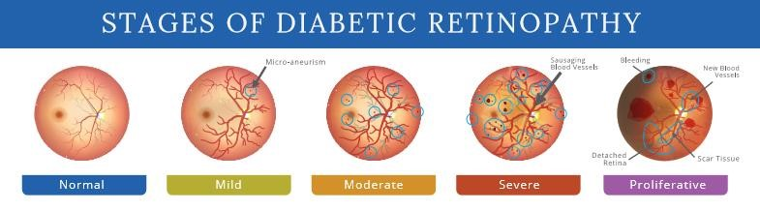 Fig:1.2.1 Stages of Diabetic Retinopathy

CHAPTER 2

OBJECTIVES

The objectives of this research project are carefully designed to comprehensively address the challenges in diagnosing and managing diabetic retinopathy (DR):

Develop a Precise Classification Model

Objective: To design a machine learning model that accurately categorizes diabetic retinopathy images into different severity levels (No DR, Mild, Moderate, Severe, Proliferative).

Outcome: Achieve high classification accuracy, validated through extensive testing on distinct datasets to ensure reliable performance.

Implement Semi-Supervised Learning Techniques

Objective: To utilize semi-supervised learning methods that enhance model performance by combining a small set of labeled data with a larger volume of unlabeled data.

Outcome: Improve the model’s ability to generalize and perform effectively on unseen data, especially when labeled data is limited.

Optimize Image Preprocessing Procedures

Objective: To create an effective image preprocessing pipeline that includes operations such as cropping, alignment, and enhancement to prepare retinal images for optimal classification.

Outcome: Ensure that the images are of high quality and well-suited for analysis, leading to more accurate classification results.

Design an Intuitive User Interface

Objective: To develop a user-friendly interface that enables clinicians and radiologists to easily upload images, view classification results, and provide feedback.

Outcome: Facilitate smooth interaction with the system, ensuring users can efficiently operate the application with minimal training.

Ensure Data Privacy and Security

Objective: To incorporate strong security measures to protect sensitive patient data during storage and transmission, adhering to relevant regulations (e.g., HIPAA).

Outcome: Safeguard patient data and maintain trust in the system by ensuring secure handling of personal health information.

Evaluate System Performance

Objective: To define and assess performance metrics such as image processing and classification times, ensuring the system operates efficiently under different loads.

Outcome: Identify performance bottlenecks and resolve them to ensure the system provides quick and reliable results.

Conduct Validation and Testing

Objective: To implement a robust validation process that evaluates the accuracy and reliability of the classification model using separate datasets.

Outcome: Provide solid evidence of the model’s effectiveness and readiness for clinical deployment.

Facilitate Scalability

Objective: To design the system architecture in a way that can handle increasing numbers of users and images without compromising performance.

Outcome: Ensure the application can scale to meet future demands while maintaining high service standards.

Promote Ethical Use of Technology

Objective: To address ethical concerns in handling patient data and provide clear information about the system's capabilities and limitations.

Outcome: Encourage responsible use of the technology and ensure users understand its functionalities and limitations.

Contribute to Medical Research

Objective: To offer insights and findings from this project that contribute to the broader field of diabetic retinopathy research and the application of machine learning in healthcare.

Outcome: Publish research outcomes and methodologies that can be referenced by other researchers and practitioners in the field.

CHAPTER 3

EXISTING SYSTEM

An earlier method for classifying diabetic retinopathy is the Early Treatment Diabetic Retinopathy Study (ETDRS) grading system, developed in the 1980s. This system was created as a standardized approach to assess the severity of diabetic retinopathy by analyzing fundus photographs of the eye. These photographs capture the retina, including the blood vessels and other structures in the back of the eye.

The primary focus of the ETDRS grading system is on detecting specific lesions that are characteristic of diabetic retinopathy, such as microaneurysms, hemorrhages, exudates, and neovascularization. It provides a clear framework for ophthalmologists and eye care professionals to communicate the extent and progression of the disease. This system has been widely used in clinical trials and research related to diabetic retinopathy.

However, although the ETDRS grading system was widely used in the past, advancements in imaging techniques and a deeper understanding of the disease have led to the creation of more sophisticated classification systems. For instance, the International Clinical Diabetic Retinopathy Severity Scale (ICDRSS) and the integration of Optical Coherence Tomography (OCT) for evaluating retinal thickness have emerged. These newer systems offer a more thorough analysis of diabetic retinopathy and its effects on the retina.

As of September 2021, the use of multipoint attention-based semi-supervised learning for classifying diabetic retinopathy had not become a widely adopted method. Nonetheless, the field of machine learning and medical image analysis is evolving rapidly, with new methods and approaches being introduced regularly. For those looking to develop a system for diabetic retinopathy classification using semi-supervised learning with multipoint attention mechanisms, it would be important to consider the following steps and components in their development process.

3.1 Limitations of the Existing System:

The current diabetic retinopathy classification system, particularly the Early Treatment Diabetic Retinopathy Study (ETDRS) grading method and its variations, has several drawbacks:

Complexity: The existing classification systems can be difficult to understand, with technical terms and details that may not be easily comprehended by everyone.

Limited Accuracy: These methods may not always provide the most precise assessment of the condition, making it challenging for healthcare providers to determine the most effective treatment for the patient’s eyes.

Incompleteness: Current systems may not capture all the possible ways diabetic retinopathy can impact the eyes, potentially overlooking important factors.

Lack of Personalization: The existing frameworks tend to be generalized, failing to account for the individual variations in how diabetic retinopathy affects different people.

Unclear Visualization: The current approaches may not always offer a clear view of what is happening inside the eyes, making it harder for clinicians to detect all issues accurately.

Poor Predictive Capability: These methods often lack the ability to predict the future course of the disease, making it harder to foresee how the condition might progress.

Limited Consideration of Variables: The existing classification methods may not take into account all the various factors that can influence the development and progression of diabetic retinopathy.

CHAPTER 4

PROPOSED SYSTEM

The suggested approach integrates a multi-point attention mechanism with semi-supervised learning for classifying diabetic retinopathy. This model is trained using both labeled and unlabeled data within a semi-supervised learning framework. The multi-point attention mechanism is employed to concentrate on the important areas of the retina images.

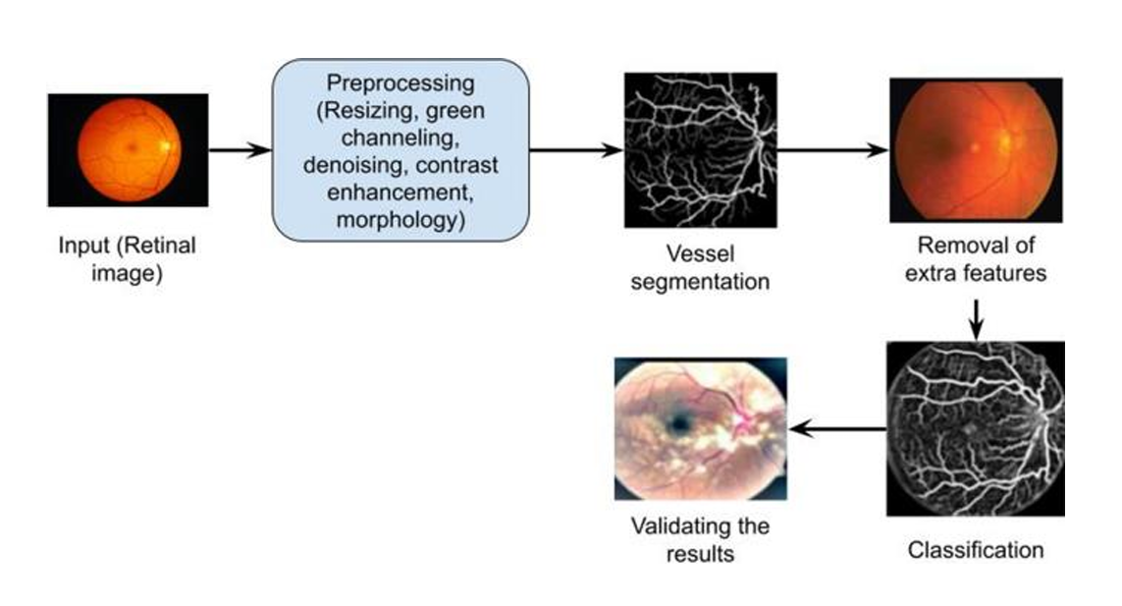

Fig: 4.1 Optical system-based data classification

4.1 Merits of the Proposed System:

The suggested approach helps reduce the cost of data labeling by utilizing unlabeled data.

It effectively extracts intelligent features for classifying diabetic retinopathy (DR).

The method requires less time and computational resources, improving efficiency.

By leveraging the latest advancements in imaging, artificial intelligence, and data analysis, the proposed system aligns with the rapid progress in these fields.

The development of this system involves contributions from a wide range of experts, making it beneficial for everyone involved.

The multi-point attention mechanism enables the model to focus on the most relevant areas of the retina image.

CHAPTER 5

SYSTEM ARCHITECTURE

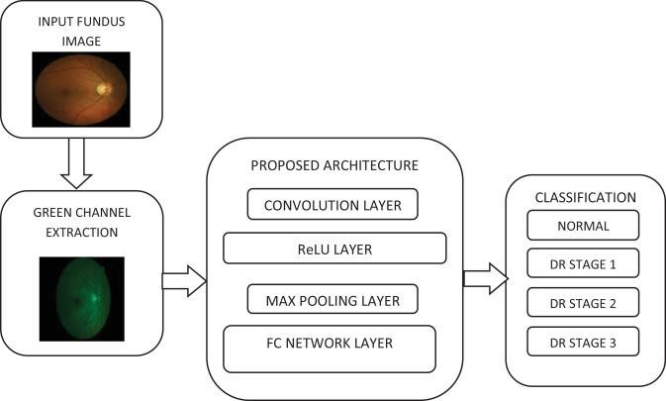
Fig:5.1 Architecture Diagram of Diabetic Retinopathy

The diagram above illustrates the architecture of the Diabetic Retinopathy classification system. Initially, the image dataset is preprocessed, meaning the raw data collected from various sources is cleaned and transformed into a suitable format for analysis. Once the data is processed, it is fed into the training model. For model training, a transfer learning approach is used, with MobileNet employed to initialize the pre-trained model. After data analysis, the K-Nearest Neighbors (KNN) algorithm is applied for classification. Subsequently, the admin selects a file to make a prediction, and the result is predicted using the TensorFlow Keras library. The output consists of five categories: No DR, Mild, Moderate, Severe, and Proliferative.

CHAPTER 6

TECHNOLOGIES USED

Programming Languages

Python: Python is the main language utilized for implementing machine learning algorithms, processing data, and developing the application. It is preferred due to its robust libraries and frameworks that support data science and machine learning tasks.

Machine Learning Frameworks

TensorFlow: This open-source library is designed for numerical computations, making machine learning tasks faster and more efficient. It is widely used for constructing and training deep learning models.

Keras: A high-level neural networks API built on top of TensorFlow, Keras simplifies the process of designing and training deep learning models.

Image Processing Libraries

OpenCV: A library that facilitates computer vision tasks, including preprocessing, augmenting, and manipulating retinal images.

PIL (Pillow): This library enables easy manipulation of images in Python, supporting various formats for opening, editing, and saving images.

Data Handling and Analysis

NumPy: A Python library essential for numerical computing, primarily used to handle arrays and perform mathematical operations on large datasets.

Pandas: A powerful library for data manipulation and analysis, providing flexible data structures and functions to manage structured data.

Visualization Tools

Matplotlib: A popular Python plotting library used to create static, animated, and interactive visualizations.

Seaborn: A statistical data visualization library built on Matplotlib, offering a high-level interface to generate attractive and informative statistical graphics.

CHAPTER 7

SOFTWARE REQUIREMENTS

7.1 Python

Python is a high-level, interpreted, object-oriented programming language with dynamic semantics. It is particularly appealing for rapid application development due to its powerful data structures, dynamic typing, and dynamic binding. These features make Python well-suited for scripting or acting as a glue language to integrate various components. The language’s straightforward syntax prioritizes readability, which helps lower the cost of program maintenance. Python supports modules and packages, promoting modular programming and code reuse. Core to Python is its focus on object-oriented programming, enabling developers to organize code effectively using classes and objects, thus improving code structure and maintainability. Python’s vast standard library supports development by offering an extensive collection of modules and packages that handle everything from file I/O and regular expressions to networking and complex data structures.

7.2 Jupyter Notebook

Jupyter Notebook is an open-source web application that enables the creation and sharing of interactive documents. It offers a dynamic environment where users can integrate code, text, equations, and visualizations into a single document, enhancing communication and collaboration across various disciplines.

One of Jupyter Notebook's main strengths is its support for multiple programming languages, with Python being the most commonly used. Users can write and execute code in interactive cells, making it particularly useful for prototyping, data analysis, and experimentation. Code cells can be executed independently, enabling quick testing and iterative development. The notebook structure is composed of two types of cells: code cells, which contain executable code, and markdown cells, which allow the addition of formatted text, headings, lists, images, and links, aiding in clear explanations and documentation of the code. This blend of code and narrative helps ensure reproducibility and facilitates knowledge sharing.

Data visualization is another area where Jupyter Notebook excels. It integrates seamlessly with libraries such as Matplotlib, Seaborn, and Plotly, allowing users to generate a variety of charts, graphs, and interactive plots directly within the notebook. This feature enhances the ability to effectively communicate insights and findings.

A unique aspect of Jupyter Notebook is its use of "kernels." Each kernel corresponds to a specific programming language, enabling code execution within the notebook. This capability allows for smooth switching between different languages within the same document, making Jupyter Notebook a versatile tool for polyglot programming and data analysis.

Jupyter Notebooks also support easy sharing and collaboration. Notebooks can be shared as files or hosted on platforms such as GitHub or JupyterHub, enabling multiple users to collaborate, review, and contribute to the work. Additionally, the support for LaTeX syntax in markdown cells allows users to include mathematical equations, which makes Jupyter Notebook especially valuable for scientific research and educational purposes.

CHAPTER 8

HARDWARE REQUIREMENTS

The hardware specifications required for the effective execution of the project include:

Processor: The system is powered by an Intel processor, which provides the necessary computational strength for tasks such as image processing, deep learning, and data analysis. This processor ensures that algorithms are executed efficiently and quickly.

GPU Support: To accelerate deep learning processes, the hardware setup includes GPU support. This boosts the performance of neural network training and enhances overall computational efficiency.

Hard Disk Capacity: A 512GB SSD (Solid State Drive) is employed to ensure fast data storage and retrieval. This storage size is sufficient to handle the large amounts of image data and models involved in the project.

RAM: The system is equipped with 16GB of RAM (Random Access Memory), providing strong multitasking abilities and ensuring smooth execution of memory-intensive operations, such as model training and image processing, even when working with large datasets.

These hardware and software configurations have been carefully selected to meet the computational needs of the project, ensuring its successful execution and reliable performance.

CHAPTER 9
MODULES
  - Data Collection and Preprocessing:
Gather a diverse and representative dataset of retinal images, ideally with labels indicating different severity levels of diabetic retinopathy.
Process the images by resizing them, normalizing pixel values, and performing other necessary preprocessing steps.
9.2 Data Splitting:
Divide the dataset into three distinct subsets: a labeled training set, a labeled validation set, and an unlabeled set.
The labeled training set contains images with ground-truth labels, used for training the model.
The labeled validation set is for hyperparameter tuning and tracking training progress.
The unlabeled dataset contains images without ground-truth labels, intended for semi-supervised learning.
9.3 Base Convolutional Neural Network (CNN):
Design a base CNN architecture that will act as the core of the model.
This CNN should be capable of extracting relevant features from retinal images.
9.4 Model Training:
Train the base CNN using the labeled training set, employing appropriate loss functions (e.g., cross-entropy loss for classification).
Apply regularization techniques to prevent overfitting, especially crucial in semi-supervised learning.
Use the labeled validation set to monitor model performance and determine when to stop training.
  - Fine-Tuning:
Fine-tune the model using the expanded training set, which now includes the pseudo-labeled data.
This step helps refine the model’s predictions on the unlabeled data.

9.6 Model Evaluation:
Evaluate the model's performance using a separate test set or through cross-validation, employing suitable evaluation metrics for diabetic retinopathy classification.
9.7 Hyperparameter Tuning and Optimization:
Experiment with various hyperparameters such as learning rate, batch size, attention mechanism parameters, and regularization strategies.
Optimize the model for improved performance.
  - Interpretability and Explainability:
Implement techniques to interpret and explain the model’s predictions, which are vital for medical applications.
  - Deployment and Clinical Validation:
Once the model performs well, consider deploying it in a clinical environment.
Work with medical professionals to validate the model’s performance and ensure its safety and effectiveness in real-world use cases.

CHAPTER 10

DESIGN DIAGRAMS

The proposed system for diabetic retinopathy (DR) classification integrates multipoint attention and semi-supervised learning. It uses a deep convolutional neural network (CNN) backbone to extract features from retinal images. A multi-point attention mechanism is employed to focus on critical regions like microaneurysms and haemorrhages. Semi-supervised learning leverages both labeled and unlabeled data, employing techniques like pseudo-labeling and consistency regularization. The model is trained on a combination of labeled and pseudo-labeled images to enhance accuracy. Cross-entropy loss is used for classification, with additional consistency loss for semi-supervised learning. Performance is evaluated using metrics like accuracy, AUC, and F1-score. The system also incorporates class imbalance handling and explainability features like Grad-CAM. The trained model is deployed via an API for real-time inference. Monitoring and retraining strategies ensure continuous improvement.

10.1 Data Flow Diagram

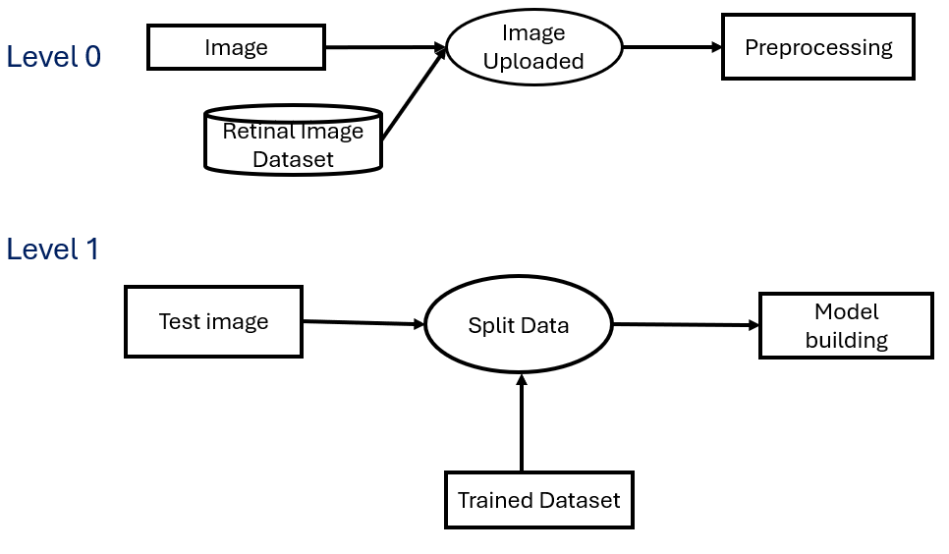

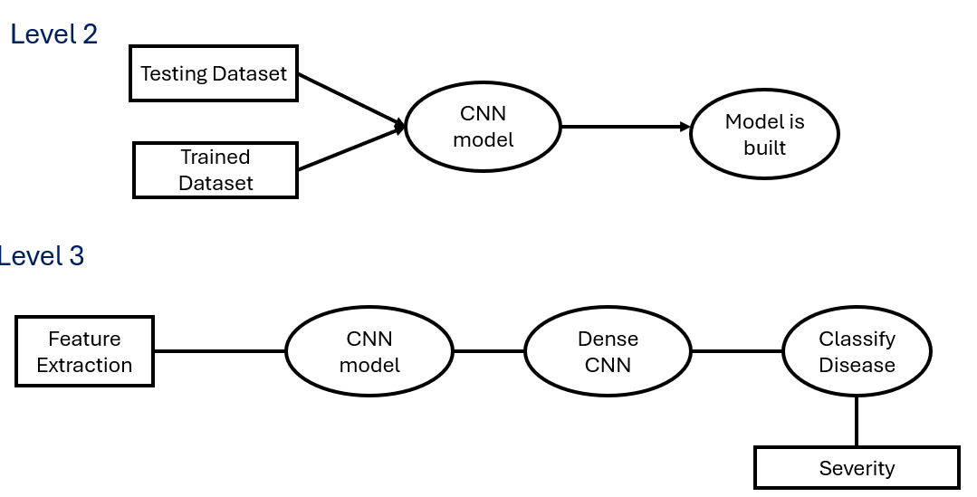

Fig 10.1 Data Flow Diagram

10.2 Class Diagram

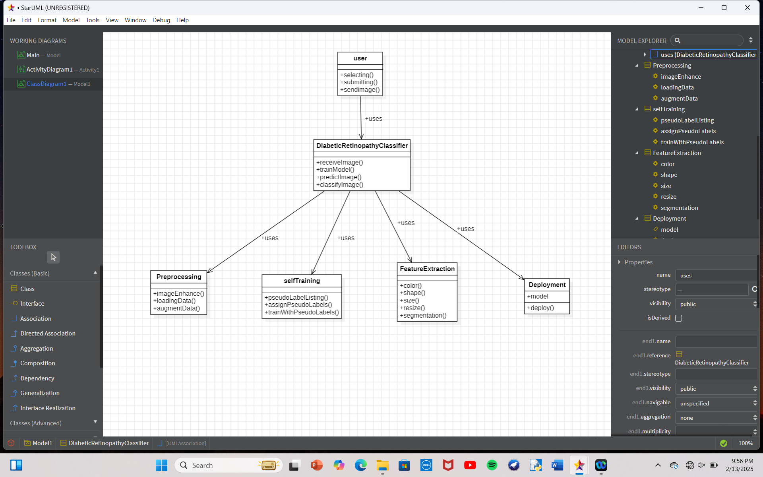

Fig 10.2 Class Diagram

10.3 Sequence Diagram

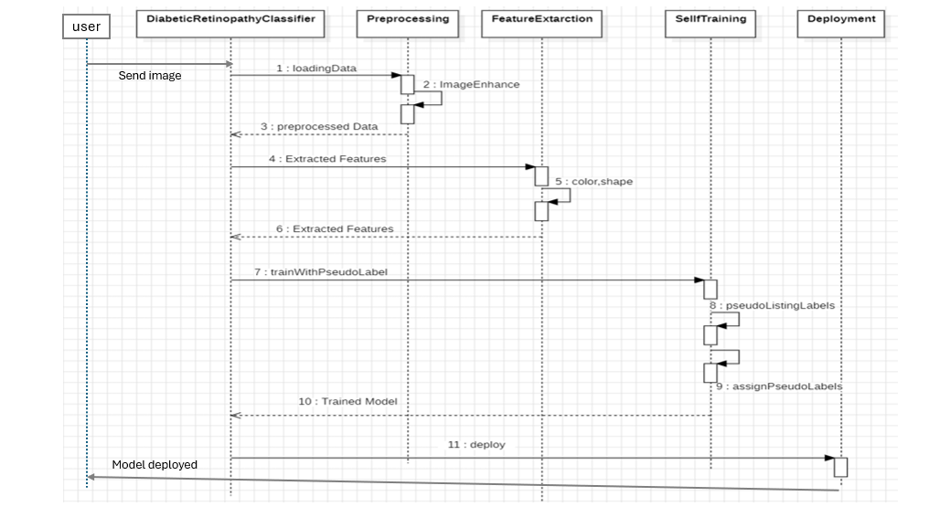

Fig 10.3 Sequence Diagram

10.4 Collaboration Diagram

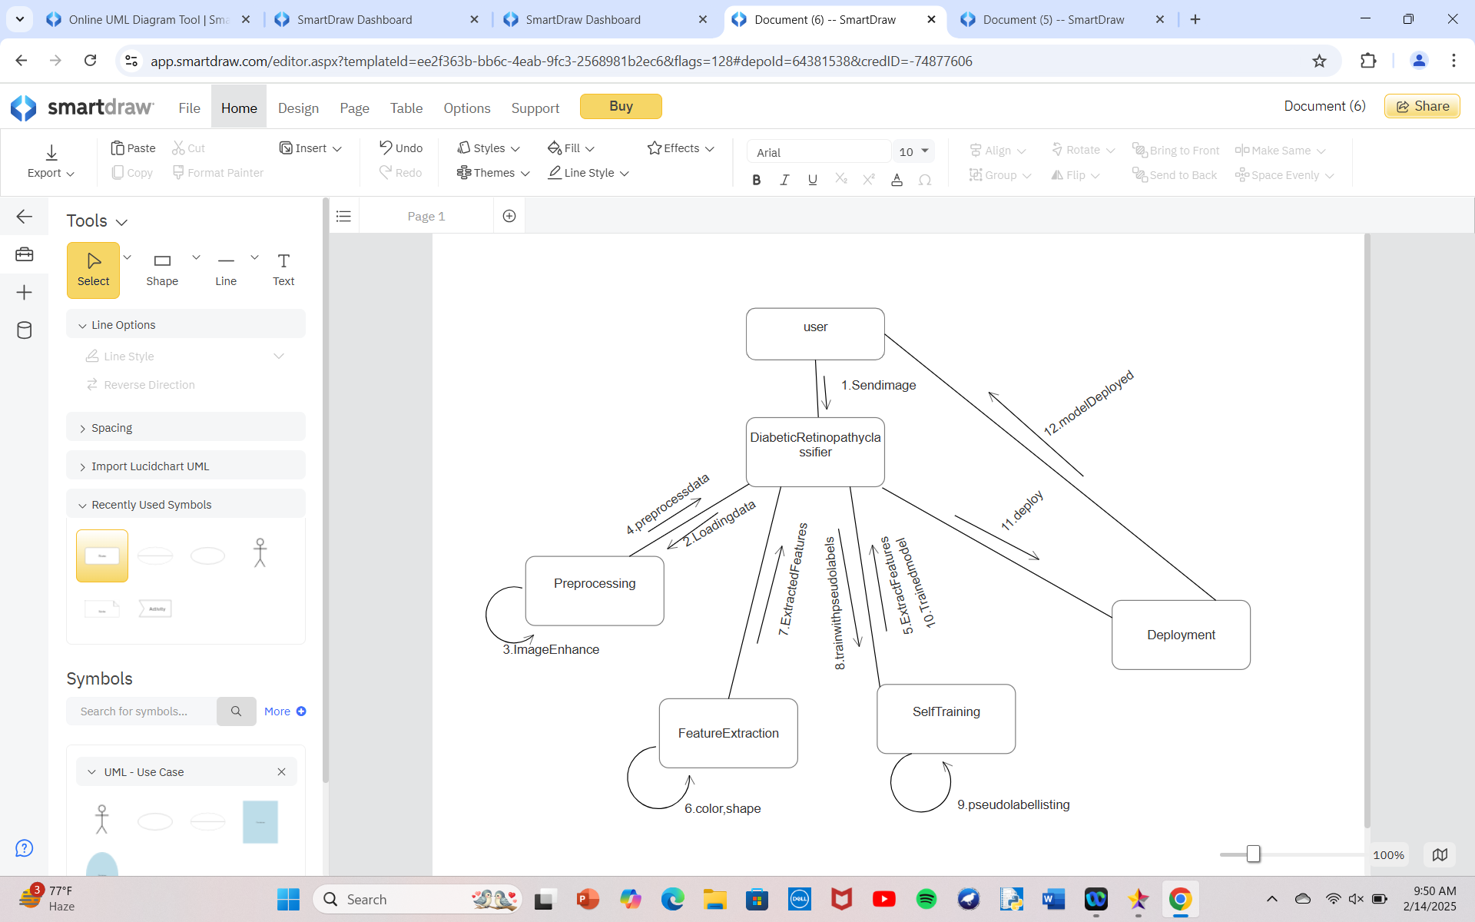

Fig 10.4 Collaboration Diagram

10.5 Use case Diagram

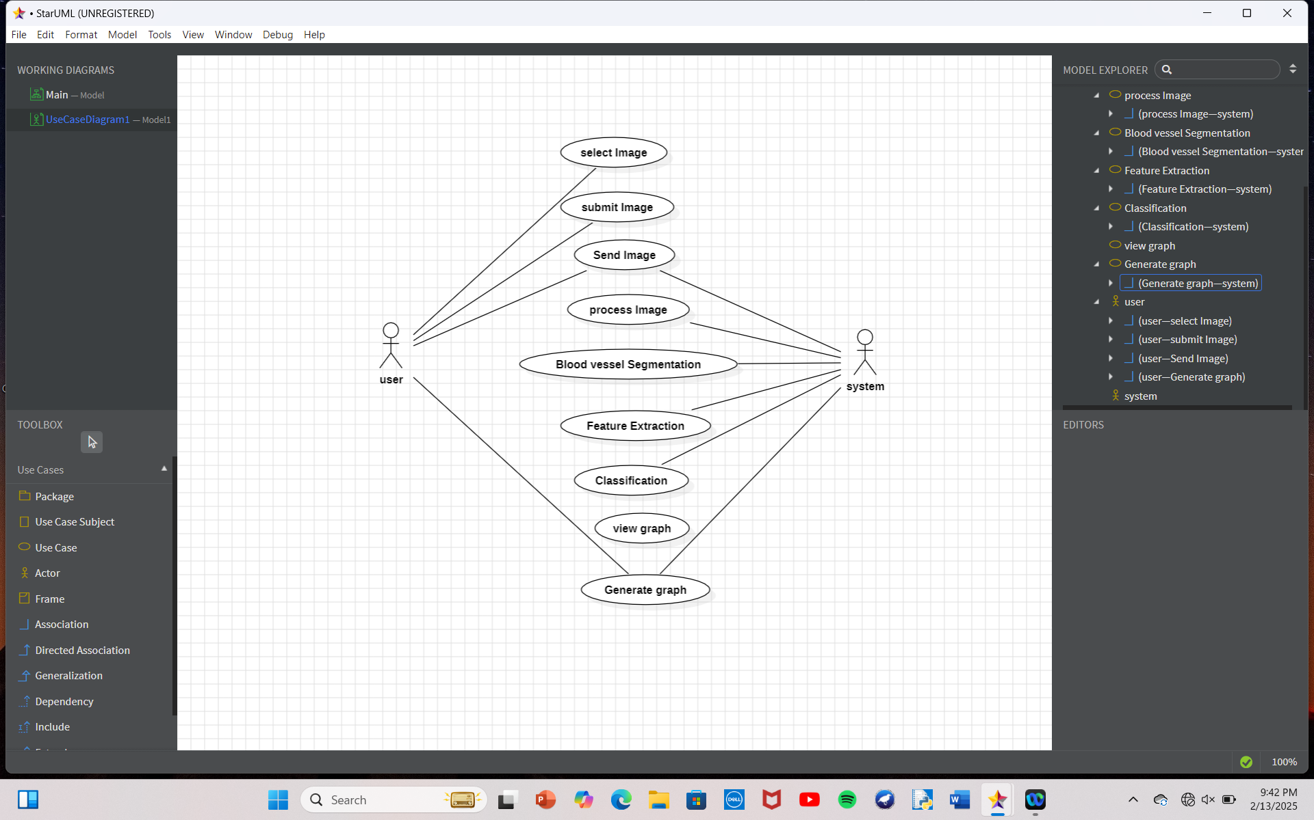

Fig 10.5 Use case Diagram

10.6 Activity Diagram

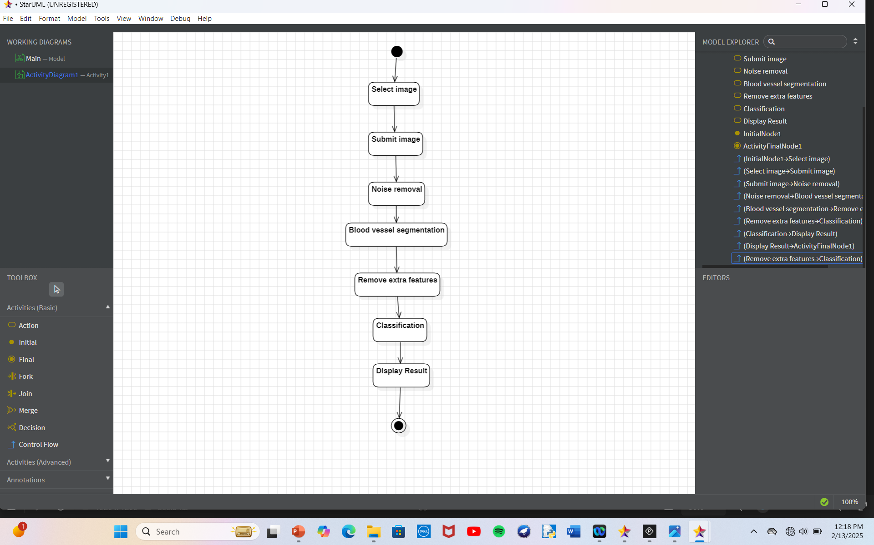

Fig 10.6 Activity Diagram

